A MICRO PROJECT REPORT
ON
"WATER QUALITY PREDICTION SYSTEM"

Subject: Foundation if Artificial Intelligence
(Course Code:2ADPC204)

Submitted in partial fulfilment of the requirement for
the award of the Degree in SY (AI &DS)

SUBMITTED BY
Rohini Sambhaji Mali
Roll No.: 2028

UNDER THE GUIDANCE OF
Ms. Priyanka Suryawanshi.

Annasaheb Dange College of Engineering and Technology,Ashta
Department of AI &DS
Academic Year: 2026–2027
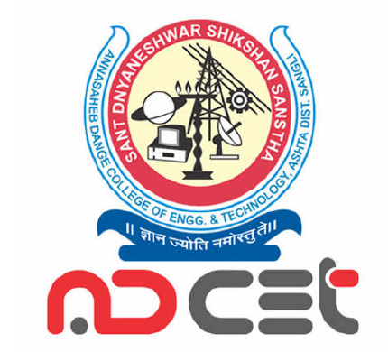

CERTIFICATE
This is to certify that Ms. Rohini Sambhaji Mali of III Semester of Degree in SY B.tech of Institute ADCET, Ashta has successfully completed the micro project work entitled “Water Quality Prediction System” in the subject “Foundation Of AI & DS ” (Course Code: 2ADPC204) for the academic year 2026–2027 as prescribed in the curriculum.

Place: ____________________
Date: _____________________

________________________
Subject Teacher
(Signature)

ACKNOWLEDGEMENT
I would like to express my sincere gratitude to my project guide Prof. Mrs. Priyanka Suryawanshi for valuable guidance and support throughout this micro project on “Water Quality Prediction System.” I am also thankful to Mrs.Asma Shaikh, the Head of the Department and the Our Director Dr. L.Y.Waghmode. of ADCET, Ashta for providing the facilities required to complete this work. Finally, I thank all teaching and non-teaching staff, my family, and my friends who helped me directly or indirectly in completing this project.

Rohini Sambhaji Mali
Roll No. 2028

INDEX
Sr. No. | Title | Page No.
1 | Aims / Benefits of the Micro Project | 5
2 | Course Outcomes Achieved | 5
3 | Literature Review | 5
4 | Actual Methodology Followed | 6
5 | Actual Resources Used | 6
6 | Outputs of the Micro Project | 7
7 | Skills Developed | 7
8 | Applications of the Micro Project | 7
9 | Conclusion | 8
10 | References | 8

MICRO PROJECT REPORT
WATER QUALITY PREDICTION SYSTEM

Aims / Benefits of the Micro Project
Aim:
To develop a simple system that uses water-quality parameters to estimate whether a water sample is likely to be suitable for use or requires further testing.
Objectives:
To understand important water-quality parameters such as pH, turbidity, dissolved solids, and temperature.
To organize water-quality readings and use them as input for a basic prediction model or rule-based system.
To display the predicted result in a simple and understandable form.
To spread awareness about the importance of testing water before drinking it.
Benefits:
Helps users understand basic water-quality information.
Can support preliminary screening of water samples.
Provides a simple way to record and review sample readings.
Encourages timely laboratory testing when results are uncertain or concerning.

2. Course Outcomes Achieved
The following course outcomes describe the learning demonstrated through this educational micro project. Update the CO numbers and wording according to the official syllabus, if required.
CO1: Identify a real-life problem related to water quality.
CO2: Collect, organize, and interpret basic water-quality data.
CO3: Apply basic programming or data-analysis concepts to produce a prediction.
CO4: Present results clearly and document the project.

3. Literature Review
Water quality is assessed using physical, chemical, and biological characteristics. Common measurements include pH, turbidity, total dissolved solids (TDS), temperature, and dissolved oxygen. These measurements help describe the condition of a water sample, but no single parameter can confirm that water is safe to drink.
Water-quality monitoring can use laboratory testing, sensor-based measurements, and data-analysis methods. A prediction system may apply predefined rules or a machine-learning model trained on labelled sample data. The reliability of the result depends on the quality and representativeness of the data, correct sensor calibration, and suitable validation.
For this microproject, a simple educational prototype is proposed. Its output is only a preliminary indication and must not be treated as certification of drinking-water safety.

4. Actual Methodology Followed
The system development methodology is organized into the following steps:
Define the problem: provide a preliminary interpretation of water-quality readings.
Choose input parameters: pH, turbidity, TDS, and temperature (additional parameters may be added if data is available).
Prepare a small dataset from reliable, documented sample readings or clearly labelled demonstration data.
Clean and organize the readings in a spreadsheet or Python dataset.
Apply a simple rule-based classification or a basic machine-learning model, if a suitable labelled dataset is available.
Display the input values and the output category, such as “Further testing recommended” or “Within selected parameter limits.”
Test the system with sample inputs and check whether the outputs follow the defined rules.
Document the limitations and recommend laboratory testing for decisions about drinking-water safety.
Suggested workflow: Water sample → Parameter readings → Data processing → Prediction/rule check → Result display → Laboratory confirmation when needed.

5. Actual Resources Used
The project can be implemented using the following resources, depending on the final software setup:
Hardware: computer/laptop; optional pH, turbidity, and TDS sensors if a hardware prototype is built.
Software: Python or Microsoft Excel; a code editor such as Visual Studio Code (if using Python).
Data: documented water-quality readings or an openly available dataset with source details.
Reference material: water-quality guidance from recognized public-health or environmental agencies.

6. Outputs of the Micro Project
The system output is a simple interface, spreadsheet, or program that accepts water-quality readings and displays a preliminary interpretation based on the selected rules or trained model.
Illustrative example only (not a real sample or a validated safety result):
Parameter | Example input | Purpose
pH | 7.2 | Indicates acidity/alkalinity
Turbidity | 2 NTU | Indicates cloudiness
TDS | 250 mg/L | Indicates dissolved substances
Temperature | 25 °C | Context for sample conditions
Example display: “Readings entered successfully. Compare each parameter with the selected standard. This prototype does not certify that the sample is safe to drink.”
For final submission, add a screenshot of the tested application here if a working prototype has been created.

7. Skills Developed
Problem identification and analytical thinking.
Basic data collection, cleaning, and interpretation.
Programming or spreadsheet skills.
Testing, debugging, and result interpretation.
Technical report writing and presentation skills.

8. Applications of the Micro Project
Educational demonstrations of water-quality monitoring.
Preliminary review of water samples before laboratory analysis.
Awareness programs in schools, colleges, and communities.
Prototype development for sensor-based environmental monitoring.
Data recording and comparison across sampling dates.

9. Conclusion
The Water Quality Prediction System demonstrates how water-quality readings can be organized and interpreted using simple rules or a basic data-analysis model. It helps explain the role of parameters such as pH, turbidity, TDS, and temperature in water monitoring. The accuracy of a prediction depends on reliable data and proper testing. This project is an educational screening tool only; it cannot replace certified laboratory analysis or confirm that water is safe to drink.

10. References
World Health Organization (WHO), Guidelines for Drinking-water Quality, available at: https://www.who.int/teams/environment-climate-change-and-health/water-sanitation-and-health/water-safety-and-quality/drinking-water-quality-guidelines
U.S. Environmental Protection Agency (EPA), Information about drinking water quality: https://www.epa.gov/ground-water-and-drinking-water
Course notes and laboratory material on data analysis / programming (add the exact title used).
Dataset source (add the dataset name, organization, and URL if a dataset is used).
Actual Resources Used

Hardware:
Computer or Laptop
Keyboard and Monitor

Software:
Operating System: Windows
Programming Languages: HTML, CSS, JavaScript
Code Editor: Visual Studio Code (VS Code)
Web Browser: Google Chrome

Other Resources:
Water quality parameters and sample data
Information about water pollution and water quality
Online learning materials and tutorials
Internet connection for research and development

OUTPUT:

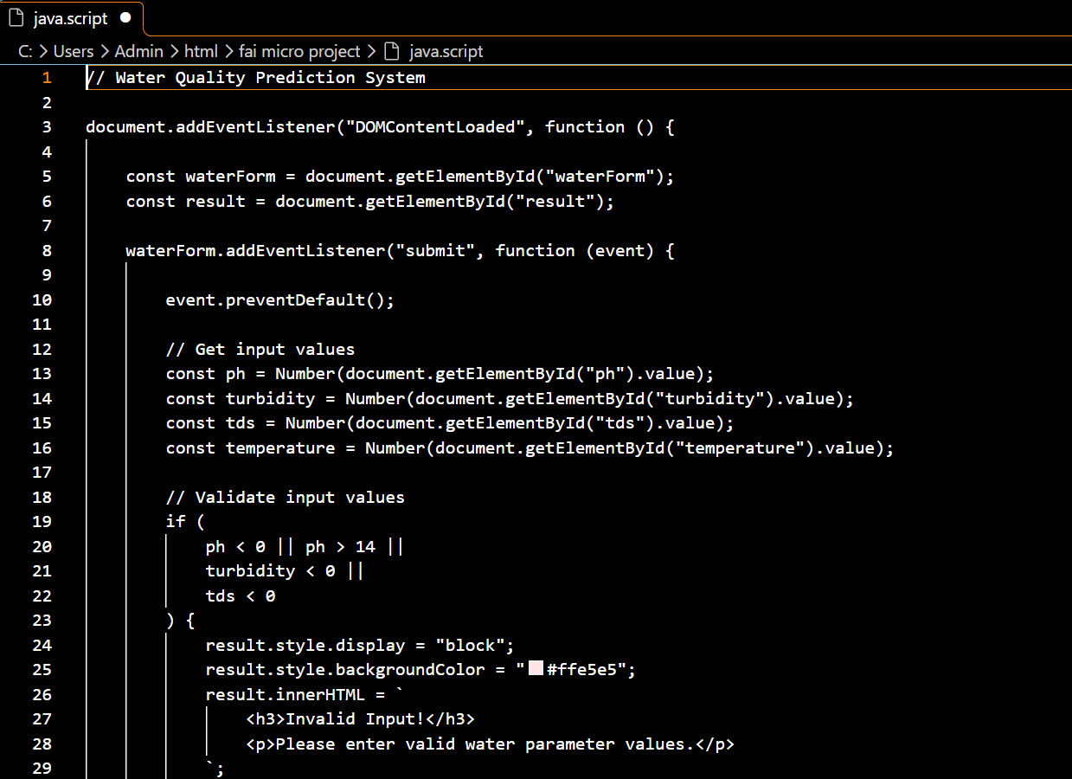

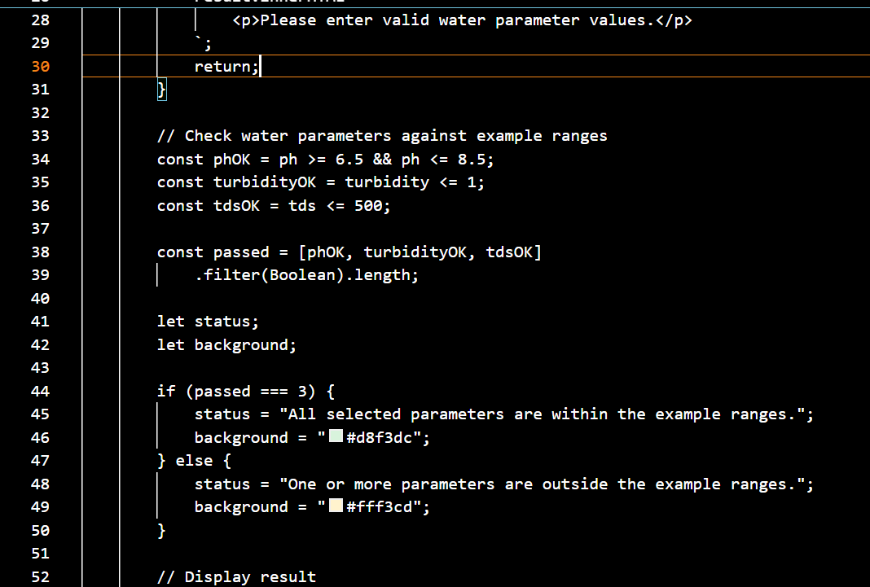
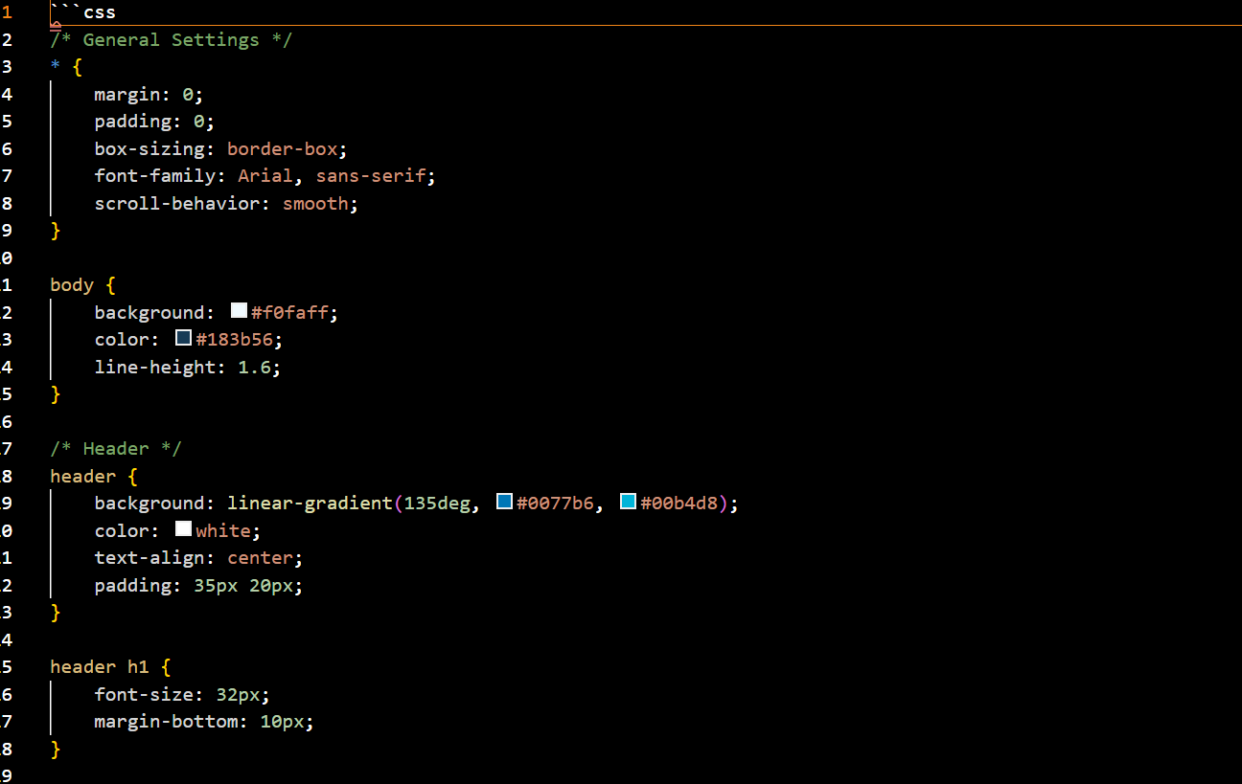

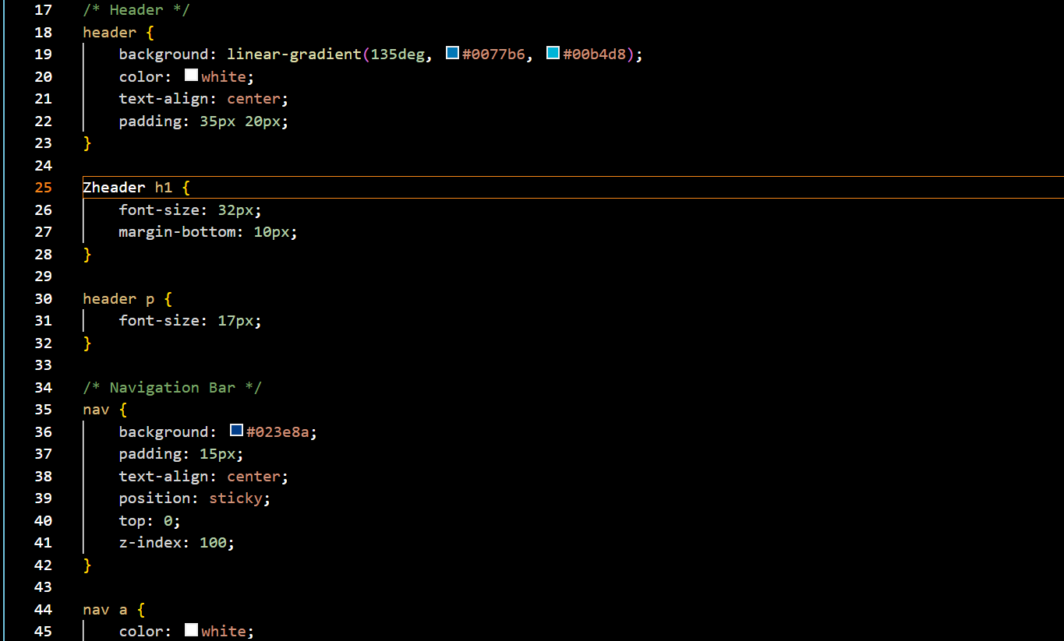

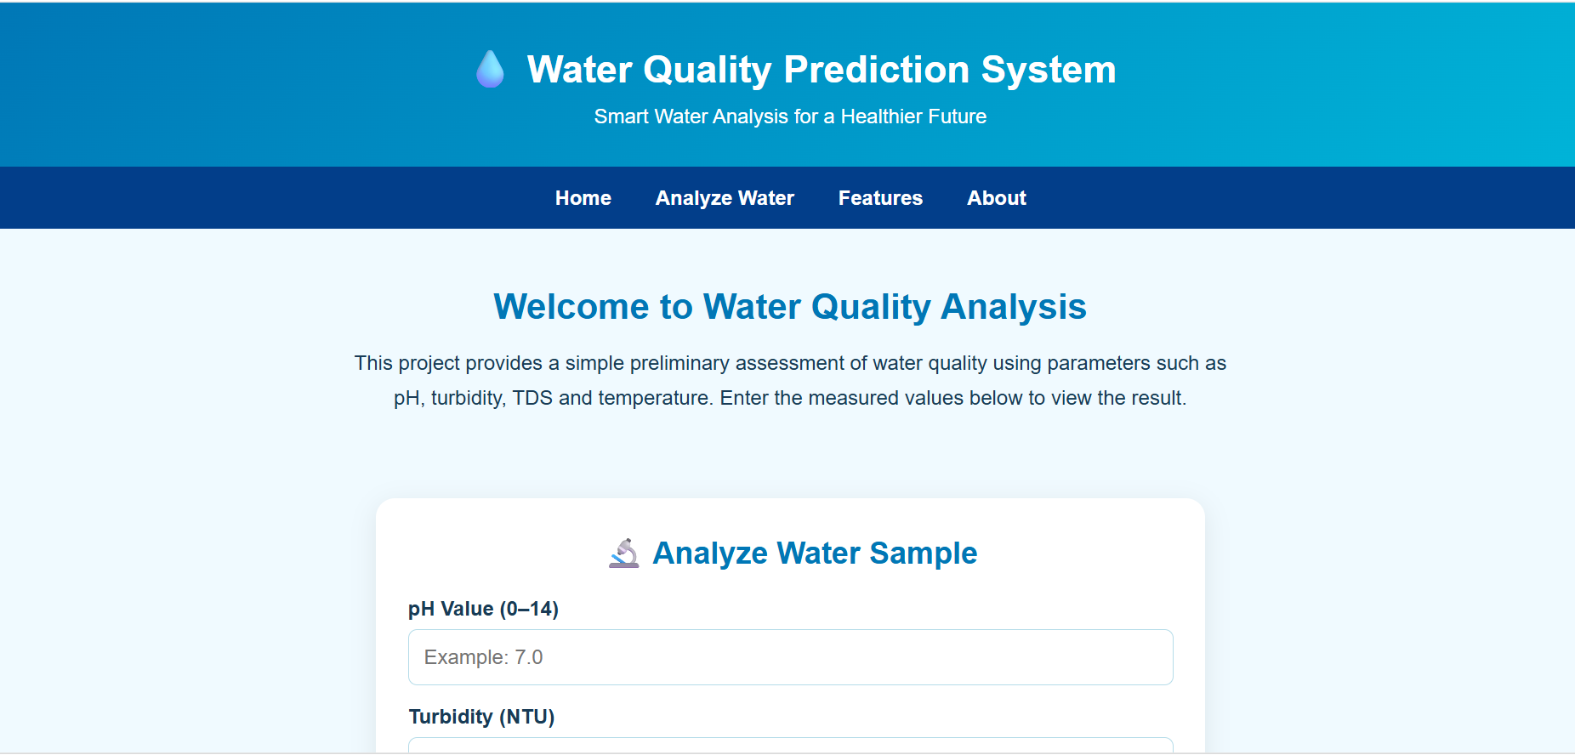
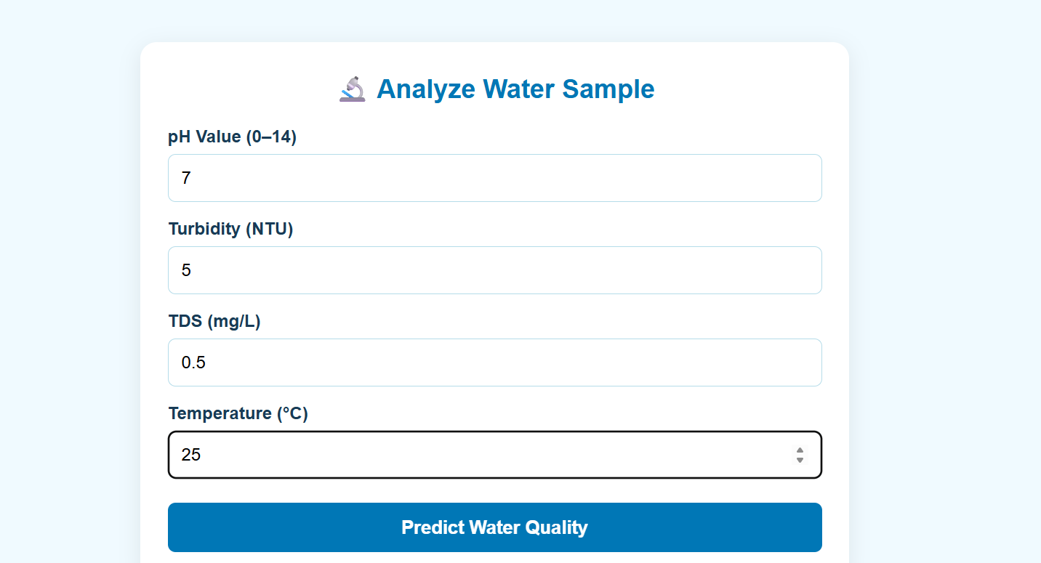

Skills Developed
- Basic understanding of water quality parameters.
- Logical thinking and problem-solving.
- HTML programming.
- CSS styling and web designing.
- JavaScript programming.
- Error detection and debugging.
- Basic understanding of water quality analysis.
- Software development skills.
2. Applications of the Micro Project
- Water quality monitoring.
- Drinking water quality assessment.
- Household water testing awareness.
- Schools and colleges for educational purposes.
- Water treatment plant monitoring support.
- Environmental awareness programs.
- Preliminary analysis of water samples.
3. Conclusion
The Water Quality Prediction System helps users perform a preliminary assessment of water quality using parameters such as pH, turbidity, TDS, and temperature. It provides a simple and user-friendly interface for entering water parameter values and viewing the results. This project helps improve awareness about water quality and demonstrates the use of web technologies in water analysis. However, laboratory testing is required to confirm whether water is safe for drinking.
4. References
- W3Schools – HTML Tutorial.
- W3Schools – CSS Tutorial.
- W3Schools – JavaScript Tutorial.
- MDN Web Docs – HTML, CSS and JavaScript documentation.
- Educational materials related to water quality parameters.
- World Health Organization (WHO) – Guidelines for Drinking-water Quality.

